A Project Report On

“Restaurant Management System”
Submitted in Partial Fulfilment of Requirements:
For the Award of the Degree
BACHELOR OF COMPUTER APPLICATION


SRI MAHAVEERA FIRST GRADE COLLEGE
KODANGALLU POST, MOODBIDRI – 574197

Department of Computer Science


PROJECT ASSOCIATES:
Nithesh (U05FZ22S0008)
Suranjit (U05FZ22S0010)
Lathesh (U05FZ22S0017)

Under the valuable guidance of:
Ms. Aruna
Department of Computer Science Sri Mahaveera College Moodbidri


DEPARTMENT OF COMPUTER SCIENCE

CERTIFICATE
This is to certify that the project work entitled “Restaurant Management System” has been carried out by Nithesh (U05FZ22S0008), Suranjit (U05FZ22S0010),
Lathesh (U05FZ22S0017) students of VI Semester BCA, in partial fulfilment of the
requirements to the completion of VI Semester, Bachelor of Computer Applications of Mangalore University during the year 2024-25.

Head of the Department Mr. Sandeep
Department of Computer Science Sri Mahaveera College Moodbidri
Internal Guide Ms. Aruna
Department of Computer Science Sri Mahaveera College Moodbidri

EXAMINERS:

DATE: 30/06/2025

ACKNOWLEDGEMENT
The project is like when you put your passion and dedication on a single piece of work by enhancing our knowledge and opening our minds for the technology and it's an immense happiness when the project that we have worked so hard to build comes out to be the way we have always thought it would be.
Making such a complex project in a limited time is a challenge in itself. So, there are a lot of people who always have our back when we run out into problems. Those people lift us up and we couldn't have imagined our project turning out so goo without them.
First of all, we would like to thank them almighty god for showering his abundant blessing on us. And I'm grateful to our Principal Dr. Radhakrishna for supporting us throughout the project development time and providing us to use all the facilities of the college needed for the environment.
We would like to thank Mr. Sandeep, Head of Department of Computer Science, Sri Mahaveera College, Moodbidri for all the concern and support extended throughout the project.
We express my heart full thank to Ms.Aruna, lecturer Department of Computer Science, for their encouragement and support extended in completing the project.
Finally, the word of thanks goes to my family and friends for guiding encouraging and inspiring me all through the project.
Thank you all.

Date:30/06/2025 Place: Moodbidri

DECLARATION
We hereby declare that our project entitled "Restaurant management System" by us for the partial fulfilment for the award of degree of Bachelor in Computer Applications, of Mangalore University embodies the result of our project work carried out under the direct supervision, guidance and the support of Ms. Aruna our internal guide, during the year 2024-2025.
We further declare that the part of this project has not been previously submitted to any other examination or institution.

Date: 30/06/2025
Place: Moodbidri

SYNOPSIS

Title of the Project:

Introduction:

SYNOPSIS

RESTAURANT MANAGEMENT SYSTEM
The Restaurant Management System is a website that helps restaurant owners and staff manage their daily work more easily. It is made to handle things like taking customer orders, booking tables, showing the menu, and getting feedback from customers.
In many restaurants, these jobs are done by writing things down or telling each other directly, which can take a lot of time and may lead to mistakes. This system makes everything easier by doing it online. It is simple to use, and anyone working in the restaurant can learn to use it quickly.
The main idea is to save time, avoid confusion, and give better service to customers. It helps the restaurant run smoothly and more professionally.

Objectives of project:
- To help restaurant staff take orders and manage work online.
- To make it easy for customers to book tables.
- To keep all order and menu details safe and well-organized.

Software specification:

Frontend:
HTML
CSS
Backend:
PHP
MySQL
IDE(Editor):
Visual Studio Code
Database:
MySQL
Platform:
XAMPP
Operating System:
Window 7 or Above

Hardware Requirements

RAM:
2 GB or more
Processor:
Pentium IV or higher

Future scope of the project:
This project can be improved in the future by adding more useful features, such as:
- Making a mobile app for customers and staff.
- Using AI to suggest popular dishes or manage food stock.
- Allowing online food ordering and delivery.
- Adding reports to track daily sales and performance.
- Connecting with other services like payment apps or delivery partners.
- Improving the system regularly based on feedback.
Conclusion:

The Restaurant Management System helps restaurants manage their work more easily and quickly.
It reduces manual work like writing down orders or checking table bookings.
The system saves time, avoids mistakes, and helps give better service to customers.
It makes the restaurant more organized, efficient, and professional.
Ask ChatGPT

SOFTWARE REQUIREMENT SPECIFICATION

Introduction :
The Restaurant Management System is an online platform that helps restaurants manage food orders, table bookings, menu items, and customer details. The main goal is to create a system that is easy for staff to use and helps keep the restaurant work organized.
This system is helpful during busy times when there are many customers. It saves time, reduces mistakes, and keeps all the information safe and easy to update or search. It also helps give better and faster service to customers.

Purpose of the project:

- To build a website that helps restaurants manage their work easily and quickly.
- To take food orders and table bookings in an organized way.
- To let customers view the menu, place orders, and book tables online.
- To give restaurant staff tools to manage menus, reservations, and customer details.
- To reduce manual work and paper records by keeping everything digital

Scope of the project:
The Restaurant Management System is made for restaurants, cafés, or food businesses. It allows:

- Customers to check the menu, order food, or book a table.
- Staff to update menu items and track customer orders.
- Admins to manage users, food items, and table reservations.
- Staff to view order history, bookings, and customer feedback.
- Storing all important information like customer names, orders, and contact info safely.

Definition, Acronyms, Abbreviation:

RMS – Restaurant Management System
HTML – HyperText Markup Language (used for front-end design)
CSS – Cascading Style Sheets (used for styling web pages)
PHP – Hypertext Preprocessor (used for server-side coding)
MySQL – Database system used for storing user data
Admin – A person who manages the system and has special access
User – Any person who registers on the platform as a donor or recipient
XAMPP – A software bundle that includes Apache, MySQL, PHP, and Perl

Functional Requirements:

The Restaurant Management System provides several useful functions to help the restaurant run smoothly. Users such as staff or admins can register and log in using a username and password. Once logged in, customers can view the food menu, place food orders, and book tables online. The staff can manage these orders, update their status, and handle table reservations. Admins have access to additional features, such as adding, editing, or removing menu items, user accounts, and reservation details. They can also view sales reports and post announcements like special discounts or events. The system stores all information such as order history, customer details, and current table availability, making it easy to track and manage everything in one place.

Non-functional Requirements:

To ensure a good experience for all users, the system also needs to meet certain non-functional requirements. It should be simple and easy to use, even for people without technical knowledge. The system must be secure and protect personal data like usernames, passwords, and customer contact details. It should load quickly and work smoothly, even when many people are using it at the same time. The system must be available all the time, especially during the restaurant’s working hours. It should also be able to grow and handle more users or data in the future without slowing down. Finally, the system should be easy to maintain, so updates and changes can be made without causing any issues.

Hardware Requirements:

CPU | Pentium IV or higher
HARD DISK SPACE | 250 GB or above
RAM | 2GB or above

Software Requirement:

Database | MySQL 5.4
Server | XAMPP
Language | PHP,, HTML, CSS
Documentation Tools | MS Word
Operating System | Windows 11
Web browser | Any browser

SYSTEM DESIGN

OVERVIEW:
A system design is as an integrated set of components that accomplish a defined objective. The process of systems design includes defining software and hardware architecture, components, modules, interfaces, and data to enable a system to satisfy a set of well-specified operational requirements.

ARCHITECTURE OF PROPOSED SYSTEM/SYSTEM DESIGN:

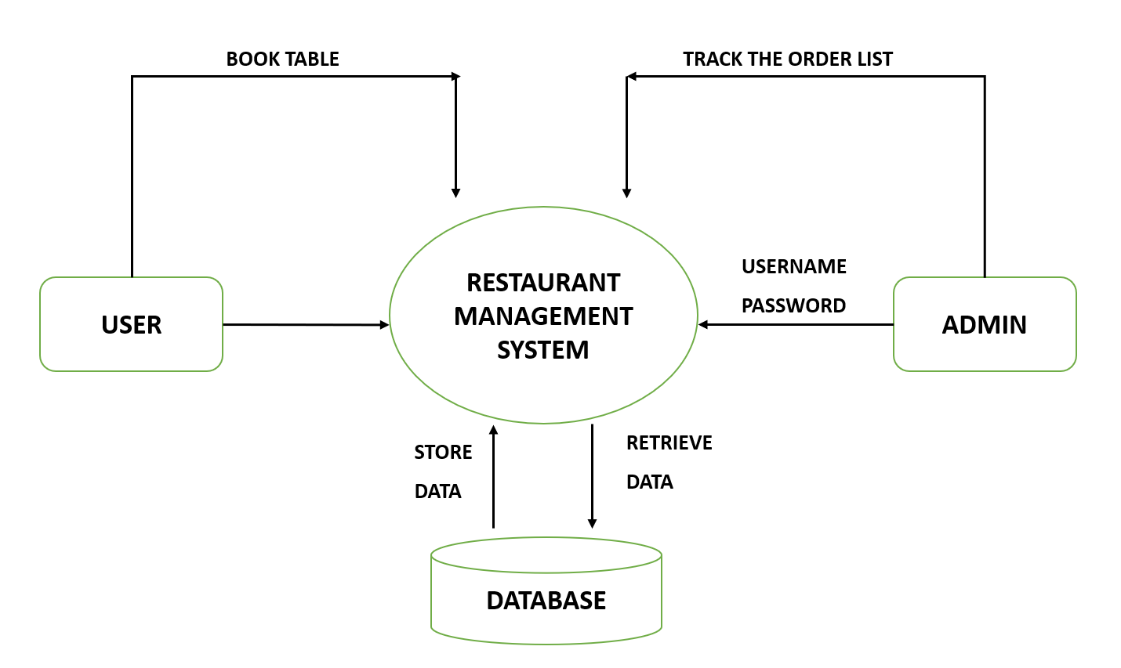

DATA FLOW DIAGRAM:
A data flow diagram (DFD) is a structured analysis and design tool that can be used for flow charting in place of or in association with information oriented and process-oriented system flowchart. A DFD is network that describes the flow of data and the processes that change or transform data throughout a system.
Dataflow models are used to show how data flows through sequence of processing steps. The data is transformed at each step before moving on to the next stage. These processing steps or transformations are program functions where data flow diagrams are used to document a software design.

LEVEL 0 DFD:
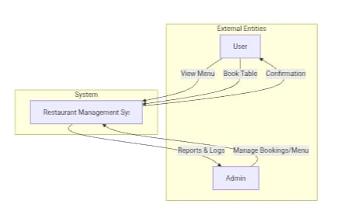
LEVEL 1 DFD:

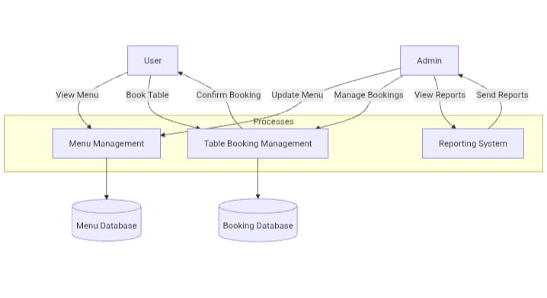

LEVEL 2 DFD:

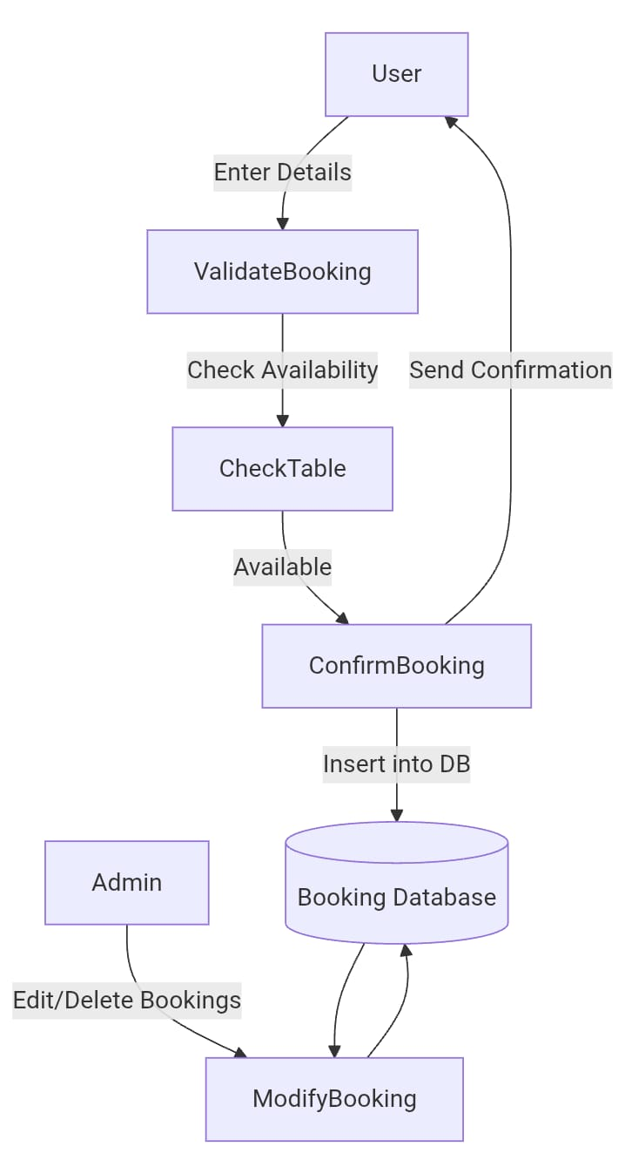

ENTITY-RELATIONSHIP DIAGRAM:
It is also called as entity relationship module, is a graphical representation of entities and their relationship to each other, typically used in computing in regard to the organization of data within databases or information systems. It is a specialized graphic that illustrates the relationship between entities in a database.

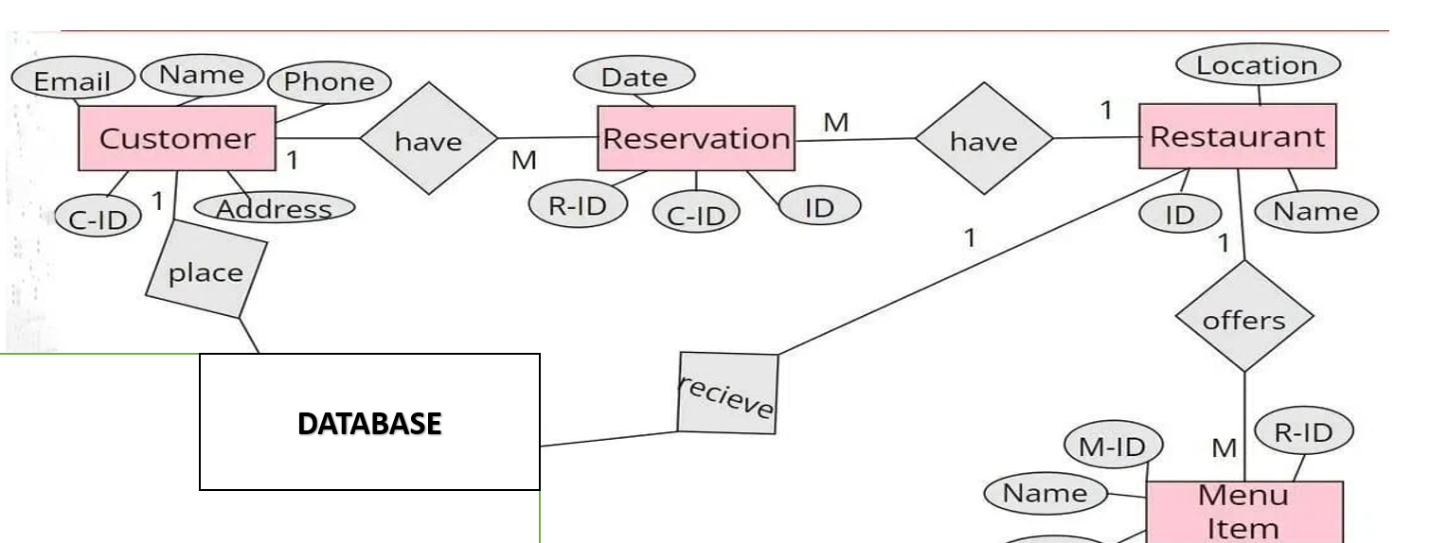

DATABASE DESIGN

DATABASE DESIGN:
Database design is the process of producing a detailed data model of a database. This data model contains all the needed logical and physical design choices and physical storage parameters needed to generate a design. It contains all the logical design and physical design parameters and attributes. It will be used to create a database. The data model should address all the attributes in great detail for each entity.

Bookings:

Attribute | Datatype | Constraint
ID | INT | AI
NAME | VARCHAR (50) | NOT NULL
EMAIL | VARCHAR (50) | NOT NULL
PHONE | DECIMAL (10) | NOT NULL
BOOKING_DATE | DATE | NOT NULL
BOOKING_TIME | TIME | NOT NULL
GUESTS | VARCHAR (5) | NOT NULL
SPEACIAL_REQUEST | TEXT | NOT NULL
CREATED_AT | TIMESTAMP | NOT NULL

PROGRAM CODE LISTENING

100.php:

<!DOCTYPE html>
<html lang="en">
<head>
<meta charset="UTF-8">
<meta name="viewport" content="width=device-width, initial-scale=1.0">
<title>Restaurant Website</title>
<link rel="stylesheet" href="https://cdnjs.cloudflare.com/ajax/libs/font-awesome/6.0.0/css/all.min.css">
<link rel="stylesheet" href="100.css">
</head>
<body>
<form action="100.php" method ="post"></form>
<nav>
<div class="nav-left">
<div class="nav-links">
<a href="100.html">Home</a>
<a href="about.html">About</a>
<a href="menu.html">Menu</a>
<a href="booking.php">Book Table</a>
</div>
</div>
<div class="nav-right">
<div class="icons">
<i class="fas fa-home-chimney"></i>
</div>
<div class="account-dropdown">
<div class="icons">
<a href="admin_login.php"><i class="fas fa-user"></i></a>
</div>
<div class="dropdown-content">
<a >Admin</a>
</div>
</div>
</div>
</nav>
<div class="slider">
<div class="slide active">
<img src="Home image/restu interior.avif" alt="Restaurant Interior">
<div class="slide-content">
<h1>Enjoy<span> Delicious Food</span> in Your Healthy Life</h1>
<p>Experience fine dining at its best</p>
<a href="menu.html" class="cta-button">View Menu</a>
</div>
</div>
</div>
<section class="special-foods">
<h2>Today's Special</h2>
<div class="food-grid">
<div class="food-item">
<img src="Home image/pasta.webp" alt="Special Pasta">
<div class="food-info">
<h3>Creamy Garlic Pasta</h3>
<p>Fresh homemade pasta with creamy garlic sauce</p>
</div>
</div>

<div class="food-item">
<img src="Home image/stikes.jpg" alt="Grilled Steak">
<div class="food-info">
<h3>Premium Ribeye Steak</h3>
<p>Perfectly grilled ribeye with seasonal vegetables</p>
</div>
</div>
<div class="food-item">
<img src="Home image/lava.webp" alt="Special Dessert">
<div class="food-info">
<h3>Chocolate Lava Cake</h3>
<p>Warm chocolate cake with vanilla ice cream</p>
</div>
</div>
</div>
</section>
<section class="feedback-section">
<h2>What Our Customers Say</h2>
<div class="feedback-grid">
<div class="feedback-item">
<div class="customer-info">
<h3>John Smith</h3>
<div class="stars">
<i class="fas fa-star"></i>
<i class="fas fa-star"></i>
<i class="fas fa-star"></i>
<i class="fas fa-star"></i>
<i class="fas fa-star"></i>
</div>
</div>
<p>"Amazing food and atmosphere! The service was impeccable, and the creamy garlic pasta is to die for."</p>
</div>
<div class="feedback-item">
<div class="customer-info">
<h3>Sarah Johnson</h3>
<div class="stars">
<i class="fas fa-star"></i>
<i class="fas fa-star"></i>
<i class="fas fa-star"></i>
<i class="fas fa-star"></i>
<i class="fas fa-star-half-alt"></i>
</div>
</div>
<p>"The ribeye steak was cooked to perfection! Will definitely be coming back for more."</p>
</div>
<div class="feedback-item">
<div class="customer-info">
<h3>Mike Davis</h3>
<div class="stars">
<i class="fas fa-star"></i>
<i class="fas fa-star"></i>
<i class="fas fa-star"></i>
<i class="fas fa-star"></i>
<i class="fas fa-star"></i>
</div>
</div>

<p>"Best fine dining experience in the city! The chocolate lava cake is absolutely divine."</p>
</div>
</div>
</section>
</body>
</html>

admin_login.php

<!DOCTYPE html><html lang="en">
<head>
<meta charset="UTF-8" />
<meta name="viewport" content="width=device-width, initial-scale=1.0" />
<title>Admin Login</title>
<link rel="stylesheet" href="https://cdnjs.cloudflare.com/ajax/libs/font-awesome/6.4.0/css/all.min.css">
<link href="https://fonts.googleapis.com/css2?family=Roboto:wght@400;700&display=swap" rel="stylesheet">
<style>
* {
box-sizing: border-box;
margin: 0;
padding: 0;
font-family: 'Roboto', sans-serif;
}
body {
background: linear-gradient(to right, #000428, #004e92);
height: 100vh;
display: flex;
justify-content: center;
align-items: center;
color: white;
animation: fadeIn 1s ease-in;
}
.login-container {
background: rgba(0, 0, 0, 0.6);
padding: 2rem;
border-radius: 10px;
box-shadow: 0 0 20px rgba(0, 255, 255, 0.3);
width: 100%;
max-width: 400px;
animation: slideIn 1s ease-out;
}
.login-container h2 {
text-align: center;
margin-bottom: 1.5rem;
color: #00ffff;
}
.form-group {
margin-bottom: 1.2rem;
}
.form-group label {
display: block;
margin-bottom: 0.5rem;
}
.form-group input {

width: 100%;
padding: 0.7rem;
border: none;
border-radius: 5px;
font-size: 1rem;
}
.form-group input:focus {
outline: none;
box-shadow: 0 0 5px #00ffff;
}
.submit-btn {
width: 100%;
padding: 0.8rem;
background-color: #00ffff;
border: none;
border-radius: 5px;
color: #000;
font-weight: bold;
cursor: pointer;
transition: background 0.3s ease;
}
.submit-btn:hover {
background-color: #00cccc;
}
.icon {
text-align: center;
margin-bottom: 1rem;
}
.icon i {
font-size: 2rem;
color: #00ffff;
}
@keyframes fadeIn {
from { opacity: 0; }
to { opacity: 1; }
}
@keyframes slideIn {
from {
transform: translateY(-50px);
opacity: 0;
}
to {
transform: translateY(0);
opacity: 1;
}
}
@media (max-width: 480px) {
.login-container {
padding: 1.5rem;
}
}
</style>
</head>
<body>
<div class="login-container">
<div class="icon">

<i class="fas fa-user-shield"></i>
</div>
<h2>Admin Login</h2>
<form action="admin_login.php" method="POST">
<div class="form-group">
<label for="username">Username</label>
<input type="text" id="username" name="username" required />
</div>
<div class="form-group">
<label for="password">Password</label>
<input type="password" id="password" name="password" required />
</div>
<button type="submit" class="submit-btn">Login</button>
<?php if(isset($error_message)){?>
<p style="color:red;"><?php echo$error_message;?></p>
<?php
} ?>
</form>
</div>
</body>
</html>

<?php
session_start();
if($_SERVER["REQUEST_METHOD"]=="POST"){
$username=$_POST["username"];
$password=$_POST["password"];
if($username==="manager"&&$password==="food1234"){
$_SESSION['username']=$username;
header("Location:ADMIN.php");
exit();
}else{
$error_message="Invalid username and password.Please try again";
}
}
?>

admin.php

<!DOCTYPE html>
<html lang="en">
<head>
<meta charset="UTF-8">
<meta name="viewport" content="width=device-width, initial-scale=1.0">
<title>Restaurant Website</title>
<link rel="stylesheet" href="https://cdnjs.cloudflare.com/ajax/libs/font-awesome/6.0.0/css/all.min.css">
<link rel="stylesheet" href="100.css">
</head>
<body>
<form action="100.php" method ="post"></form>
<nav>
<div class="nav-left">
<div class="nav-links">
<a href="100.html">Home</a>

<a href="about.html">About</a>
<a href="menu.html">Menu</a>
<a href="booking.php">Book Table</a>
<a href="orders.php">Orders</a>
</div>
</div>
<div class="nav-right">
<div class="icons">
<i class="fas fa-home-chimney"></i>
</div>
<div class="account-dropdown">
<div class="icons">
<a href="100.html"> <i class="fas fa-user"></i></a>
</div>
<div class="dropdown-content">
<a >Logout</a>
</div>
</div>
</nav>

<div class="slider">
<div class="slide active">
<img src="Home image/restu interior.avif" alt="Restaurant Interior">
<div class="slide-content">
<h1>Enjoy<span>Delicious Food</span> in Your Healthy Life</h1>
<p>Experience fine dining at its best</p>
<a href="menu.html" class="cta-button">View Menu</a>
</div>
</div>
</div>
<section class="special-foods">
<h2>Today's Special</h2>

<div class="food-grid">
<div class="food-item">
<img src="Home image/pasta.webp" alt="Special Pasta">
<div class="food-info">
<h3>Creamy Garlic Pasta</h3>
<p>Fresh homemade pasta with creamy garlic sauce</p>
<span class="food-price">$18.99</span>
</div>
</div>
<div class="food-item">
<img src="Home image/stikes.jpg" alt="Grilled Steak">
<div class="food-info">
<h3>Premium Ribeye Steak</h3>
<p>Perfectly grilled ribeye with seasonal vegetables</p>
<span class="food-price">$32.99</span>
</div>
</div>
<div class="food-item">
<img src="Home image/lava.webp" alt="Special Dessert">
<div class="food-info">
<h3>Chocolate Lava Cake</h3>
<p>Warm chocolate cake with vanilla ice cream</p>
<span class="food-price">$12.99</span>

</div>
</div>
</div>
</section>
<section class="feedback-section">
<h2>What Our Customers Say</h2>
<div class="feedback-grid">
<div class="feedback-item">
<div class="customer-info">
<h3>John Smith</h3>
<div class="stars">
<i class="fas fa-star"></i>
<i class="fas fa-star"></i>
<i class="fas fa-star"></i>
<i class="fas fa-star"></i>
<i class="fas fa-star"></i>
</div>
</div>
<p>"Amazing food and atmosphere! The service was impeccable, and the creamy garlic pasta is to die for."</p>
</div>
<div class="feedback-item">
<div class="customer-info">
<h3>Sarah Johnson</h3>
<div class="stars">
<i class="fas fa-star"></i>
<i class="fas fa-star"></i>
<i class="fas fa-star"></i>
<i class="fas fa-star"></i>

<i class="fas fa-star-half-alt"></i>
</div>
</div>
<p>"The ribeye steak was cooked to perfection! Will definitely be coming back for more."</p>
</div>
<div class="feedback-item">
<div class="customer-info">
<h3>Mike Davis</h3>

<div class="stars">
<i class="fas fa-star"></i>
<i class="fas fa-star"></i>
<i class="fas fa-star"></i>
<i class="fas fa-star"></i>
<i class="fas fa-star"></i>
</div>
</div>
<p>"Best fine dining experience in the city! The chocolate lava cake is absolutely divine."</p>
</div>
</div>
</section>
</body>
</html>
<?php
session_start();
if (!isset($_SESSION['admin_logged_in'])) {

header("Location: admin_login.html");
exit();
}
?>

Order.php

<!DOCTYPE html>
<html lang="en">
<head>
<meta charset="UTF-8">
<meta name="viewport" content="width=device-width, initial-scale=1.0">
<title>Restaurant Website</title>
<link rel="stylesheet" href="https://cdnjs.cloudflare.com/ajax/libs/font-awesome/6.0.0/css/all.min.css">
<link rel="stylesheet" href="100.css">
</head>
<body>
<form action="100.php" method ="post"></form>
<nav>
<div class="nav-left">
<div class="nav-links">
<a href="100.html">Home</a>
<a href="about.html">About</a>
<a href="menu.html">Menu</a>
<a href="booking.php">Book Table</a>
<a href="orders.php">Orders</a>
</div>

</div>
<div class="nav-right">
<div class="icons">
<i class="fas fa-home-chimney"></i>
</div>
<div class="account-dropdown">
<div class="icons">
<a href="100.html"> <i class="fas fa-user"></i></a>
</div>
<div class="dropdown-content">
<a >Logout</a>
</div>
</div>
</div>
</div>
</nav>
<div class="slider">
<div class="slide active">
<img src="Home image/restu interior.avif" alt="Restaurant Interior">
<div class="slide-content">
<h1>Enjoy<span>Delicious Food</span> in Your Healthy Life</h1>
<p>Experience fine dining at its best</p>
<a href="menu.html" class="cta-button">View Menu</a>
</div>
</div>
</div>
<section class="special-foods">
<h2>Today's Special</h2>

<div class="food-grid">
<div class="food-item">
<img src="Home image/pasta.webp" alt="Special Pasta">
<div class="food-info">
<h3>Creamy Garlic Pasta</h3>
<p>Fresh homemade pasta with creamy garlic sauce</p>
<span class="food-price">$18.99</span>
</div>
</div>
<div class="food-item">
<img src="Home image/stikes.jpg" alt="Grilled Steak">
<div class="food-info">
<h3>Premium Ribeye Steak</h3>
<p>Perfectly grilled ribeye with seasonal vegetables</p>
<span class="food-price">$32.99</span>
</div>
</div>
<div class="food-item">
<img src="Home image/lava.webp" alt="Special Dessert">
<div class="food-info">
<h3>Chocolate Lava Cake</h3>
<p>Warm chocolate cake with vanilla ice cream</p>
<span class="food-price">$12.99</span>
</div>
</div>
</div>
</section>
<section class="feedback-section">
<h2>What Our Customers Say</h2>
<div class="feedback-grid">
<div class="feedback-item">
<div class="customer-info">
<h3>John Smith</h3>
<div class="stars">
<i class="fas fa-star"></i>
<i class="fas fa-star"></i>
<i class="fas fa-star"></i>
<i class="fas fa-star"></i>
<i class="fas fa-star"></i>
</div>
</div>
<p>"Amazing food and atmosphere! The service was impeccable, and the creamy garlic pasta is to die for."</p>
</div>

<div class="feedback-item">
<div class="customer-info">
<h3>Sarah Johnson</h3>
<div class="stars">
<i class="fas fa-star"></i>
<i class="fas fa-star"></i>
<i class="fas fa-star"></i>
<i class="fas fa-star"></i>
<i class="fas fa-star-half-alt"></i>
</div>
</div>

<p>"The ribeye steak was cooked to perfection! Will definitely be coming back for more."</p>
</div>
<div class="feedback-item">
<div class="customer-info">
<h3>Mike Davis</h3>
<div class="stars">
<i class="fas fa-star"></i>
<i class="fas fa-star"></i>
<i class="fas fa-star"></i>
<i class="fas fa-star"></i>
<i class="fas fa-star"></i>
</div>
</div>
<p>"Best fine dining experience in the city! The chocolate lava cake is absolutely divine."</p>
</div>
</div>
</section>
</body>
</html>
<?php
session_start();
if (!isset($_SESSION['admin_logged_in'])) {
header("Location: admin_login.php");
exit();
}
?>

Booking.php

<!DOCTYPE html>
<html lang="en">
<head>
<meta charset="UTF-8">
<meta name="viewport" content="width=device-width, initial-scale=1.0">
<title>Gourmet Haven | Table Reservation</title>
<link rel="stylesheet" href="https://cdnjs.cloudflare.com/ajax/libs/font-awesome/6.4.0/css/all.min.css">
<body>
<!-- Header -->
<header class="header">
<div class="logo">
<i class="fas fa-utensils"></i>
<h1>Gourmet Haven</h1>
</div>
<nav>
<ul class="nav-links">
<li><a href="100.html">Home</a></li>
<li><a href="about.html">About</a></li>
<li><a href="menu.html">Menu</a></li>
<li><a href="#" class="active">Book a Table</a></li>
</ul>
</nav>
</header>

<!-- Main Content -->
<div class="main-container">
<div class="booking-card">

<div class="card-header">
<h1>Table Reservation</h1>
<p>Experience culinary excellence in our elegant dining space</p>
</div>

<?php
// Database connection
$host="localhost";
$username="root";
$password="";
$database="restaurant_db";

$con=new mysqli($host,$username,$password,$database);

if($con->connect_error){
die("Connection Failed...".$con->connect_error);
}

// Only process if form is submitted
if ($_SERVER["REQUEST_METHOD"] == "POST") {
// Sanitize and validate input data
$name = $_POST['name'];
$email = $_POST['email'];
$phone = $_POST['phone'];
$date = $_POST['date'];
$time = $_POST['time'];
$guests = $_POST['guests'];
$special_requests =$_POST['special_requests'];

if (empty($name) || empty($email) || empty($phone) || empty($date) || empty($time) || empty($guests)) {
echo "<div class='message error'>Please fill in all required fields</div>";
} else {
$stmt=$con->prepare("INSERT INTO bookings (name, email, phone, booking_date, booking_time, guests, special_requests, created_at) VALUES (?, ?, ?, ?, ?, ?, ?, NOW())");
$stmt->bind_param("sssssss", $name, $email, $phone, $date, $time, $guests, $special_requests);
// Validate required fields
if ($stmt->execute()) {
echo "<div class='message success'>Booking successful! We will contact you to confirm your reservation.</div>";
} else {
"<div class='message error'>Booking failed: " . $stmt->error . "</div>";
}
$stmt->close();
}
$con->close();
}
?>

<form class="booking-form" id="bookingForm" method="POST">
<div class="form-group">
<label for="name">Full Name:</label>
<input type="text" id="name" name="name" required placeholder="John Smith">
<i class="fas fa-user"></i>
</div>

<div class="form-group">

<label for="email">Email:</label>
<input type="email" id="email" name="email" required placeholder="john@example.com">
<i class="fas fa-envelope"></i>
</div>

<div class="form-group">
<label for="phone">Phone Number:</label>
<input type="tel" id="phone" name="phone" required placeholder="(123) 456-7890">
<i class="fas fa-phone"></i>
</div>

<div class="form-group">
<label for="date">Date:</label>
<input type="date" id="date" name="date" required>
<i class="fas fa-calendar-alt"></i>
</div>

<div class="form-group">
<label for="time">Time:</label>
<input type="time" id="time" name="time" required>
<i class="fas fa-clock"></i>
</div>
<div class="form-group">
<label for="guests">Number of Guests:</label>
<select id="guests" name="guests" required>
<option value="">Select number of guests</option>
<option value="1">1 Person</option>
<option value="2">2 People</option>
<option value="3">3 People</option>
<option value="4">4 People</option>
<option value="5">5 People</option>
<option value="6">6 People</option>
<option value="7+">7 or more</option>
</select>
<i class="fas fa-users"></i>
</div>
<div class="form-group">
<label for="special_requests">Special Requests:</label>
<textarea id="special_requests" name="special_requests" rows="4" placeholder="Dietary restrictions, celebration notes, etc."></textarea>
</div>
<button type="submit" class="btn-submit">Reserve Your Table</button>
</form>
</div>
</div>
<!-- Footer -->
<footer class="footer">

<div class="social-icons">
<a href="#"><i class="fab fa-facebook-f"></i></a>
<a href="#"><i class="fab fa-instagram"></i></a>
<a href="#"><i class="fab fa-twitter"></i></a>
<a href="#"><i class="fab fa-tripadvisor"></i></a>
</div>
<p>© 2023 Gourmet Haven. All rights reserved.</p>
</footer>

</body>
</html>

About.html

<!DOCTYPE html>
<html lang="en">
<head>
<meta charset="UTF-8">
<meta name="viewport" content="width=device-width, initial-scale=1.0">
<title>About Us | Our Story</title>
<link rel="stylesheet" href="100.css">
<link rel="stylesheet" href="https://cdnjs.cloudflare.com/ajax/libs/font-awesome/6.5.2/css/all.min.css">
</head>
<body>
<header>
<nav class="navbar">
<ul>
<li><a href="100.html">Home</a></li>
<li><a href="about.html">About</a></li>
<li><a href="menu.html">Menu</a></li>
<li><a href="booking.php">Book a Table</a></li>
</ul>
</nav>
</header>

<div class="about-hero">
<div class="about-overlay">
<h1>Our Story</h1>
<p>Lorem ipsum dolor sit, amet consectetur adipisicing elit. Ut voluptas in recusandae perferendis velit?<br>
Autem excepturi placeat cupiditate beatae optio assumenda at quia commodi facere, deserunt earum ipsa<br>
quaerat</p>
</div>
</div>

<section class="about-story">
<div class="story-content">
<h2>A Journey of <span class="highlight">Passion</span> & <span class="highlight">Flavor</span></h2>
<p>Founded by Chef Maria Rodriguez, our restaurant began with a simple dream: to create a place where food, family, and tradition come together. Every dish tells a story, every flavor carries a memory.</p>

<div class="story-stats">
<div class="stat-item">
<i class="fas fa-utensils"></i>
<h3>25+</h3>
<p>Years of Excellence</p>
</div>
<div class="stat-item">
<i class="fas fa-users"></i>
<h3>50K+</h3>
<p>Happy Customers</p>
</div>

<div class="stat-item">
<i class="fas fa-award"></i>
<h3>15+</h3>
<p>Awards Won</p>
</div>
</div>
</div>
<div class="story-image">
<img src="Home image/chef.png" alt="Our Chef in Action">
</div>
</section>
<section class="our-values">
<h2>What Sets Us Apart</h2>
<div class="values-grid">
<div class="value-card">
<i class="fas fa-leaf"></i>
<h3>Fresh Ingredients</h3>
<p>We source only the finest local ingredients to ensure quality in every dish.</p>
</div>
<div class="value-card">
<i class="fas fa-heart"></i>
<h3>Made with Love</h3>
<p>Every dish is crafted with passion and attention to detail.</p>
</div>
<div class="value-card">
<i class="fas fa-globe"></i>
<h3>Sustainable Practices</h3>
<p>Committed to eco-friendly operations and responsible sourcing.</p>
</div>

</div>
</section>
<section class="team-section">
<h2>Meet Our Culinary Team</h2>
<div class="team-grid">
<div class="team-member">
<img src="Home image/head chef.jpg" alt="Head Chef">
<h3>Maria Rodriguez</h3>
<p>Head Chef</p>
</div>
<div class="team-member">
<img src="Home image/sanjeev kapoor.webp" alt="Sous Chef">
<h3>Sanjeev Kapoor</h3>
<p>Sous Chef</p>
</div>

<div class="team-member">
<img src="Home image/25.jpg" alt="Garima Arora">
<h3>Garima Arora</h3>
<p>Pastry Chef</p>
</div>
</div>
</section>

<section class="testimonial-section">
<div class="testimonial-content">

<h2>What Our Customers Say</h2>
<div class="testimonial-carousel">
<div class="testimonial">
<i class="fas fa-quote-left"></i>
<p>"The best dining experience I've had in years. The attention to detail is remarkable."</p>
<h4>- Emily Johnson</h4>
</div>
</div>
</div>
</section>
</body>
</html>

Menu.html

<!DOCTYPE html>
<html lang="en">
<head>
<meta charset="UTF-8">
<meta name="viewport" content="width=device-width, initial-scale=1.0">
<title>Restaurant Menu</title>
</head>
<body>
<header>
<h1>Our Delicious Menu</h1>
</header>
<nav>
<ul>
<li><a href="100.html">Home</a></li>
<li><a href="about.html">About</a></li>
<li><a href="menu.html">Menu</a></li>
<li><a href="booking.php">Book a Table</a></li>
</ul>
</nav>
<div class="menu-container">
<!-- Vegetarian Section -->
<section class="menu-section">
<h2>Vegetarian Specialties</h2>
<div class="food-grid">
<div class="food-item">
<img src="Home image/butter masala.webp" alt="Paneer Butter Masala">
<div class="food-info">
<h3>Paneer Butter Masala</h3>
<p>Creamy cottage cheese curry in rich tomato gravy</p>

</div>
</div>

div class="food-item">
<img src="Home image/vegBiryani.webp" alt="Vegetable Biryani">
<div class="food-info">
<h3>Vegetable Biryani</h3>
<p>Aromatic rice with mixed vegetables and spices</p>
</div>

</div>
<div class="food-item">
<img src="Home image/dal makhani.jpg" alt="Dal Makhani">
<div class="food-info">
<h3>Dal Makhani</h3>
<p>Creamy black lentils cooked overnight</p>
</div>
</div>
<div class="food-item">
<img src="Home image/mashroom tikka.webp" alt="Mashroom Tikka">
<div class="food-info">
<h3>Mashroom Tikka</h3>
<p>Clay oven roasted chicken with Indian spices</p>
</div>
</div>
<div class="food-item">
<img src="Home image/gobi.jpg" alt="Cauliflower Tomato Masala">
<div class="food-info">
<h3>Cauliflower Tomato Masala</h3>
<p>Whole rosted Cauliflower with spicy tomato masala sauce</p>
</div>
</div>
<div class="food-item">
<img src="Home image/thali.jpg" alt="thali">
<div class="food-info">
<h3>Thali</h3>
<p>Punjabi thali</p>
</div>
</div>
</div>

</section>

<!-- Non-Vegetarian Section -->
<section class="menu-section">
<h2>Non-Vegetarian Delights</h2>
<div class="food-grid">
<div class="food-item">
<img src="Home image/download.jpg" alt="Butter Chicken">
<div class="food-info">
<h3>Butter Chicken</h3>
<p>Tender chicken in rich tomato and butter gravy</p>
</div>
</div>
<div class="food-item">
<img src="Home image/biriyani.jpg" alt="Chicken Biryani">
<div class="food-info">

<h3>Chicken Biryani</h3>
<p>Fragrant rice with tender chicken and aromatic spices</p>
</div>
</div>
<div class="food-item">
<img src="Home image/fish curry.jpg" alt="Fish Curry">
<div class="food-info">
<h3>Fish Curry</h3>

<p>Fresh fish cooked in coconut-based curry</p>
</div>
</div>
<div class="food-item">
<img src="Home image/motton.avif" alt="Mutton Rogan Josh">
<div class="food-info">
<h3>Mutton Rogan Josh</h3>
<p>Kashmiri style spicy mutton curry</p>
</div>
</div>
<div class="food-item">
<img src="Home image/tandoori.webp" alt="Tandoori Chicken">
<div class="food-info">
<h3>Tandoori Chicken</h3>
<p>Clay oven roasted chicken with Indian spices</p>
</div>
</div>
<div class="food-item">
<img src="Home image/chilly chicken.jpg" alt="Chilly Chicken">
<div class="food-info">
<h3>Chicken Chilly</h3>
<p>kerala style chilly chicken</p>
</div>
</div>
</div>
</section>
</div>
</body>
</html>

USER INTERFACE

Interface:

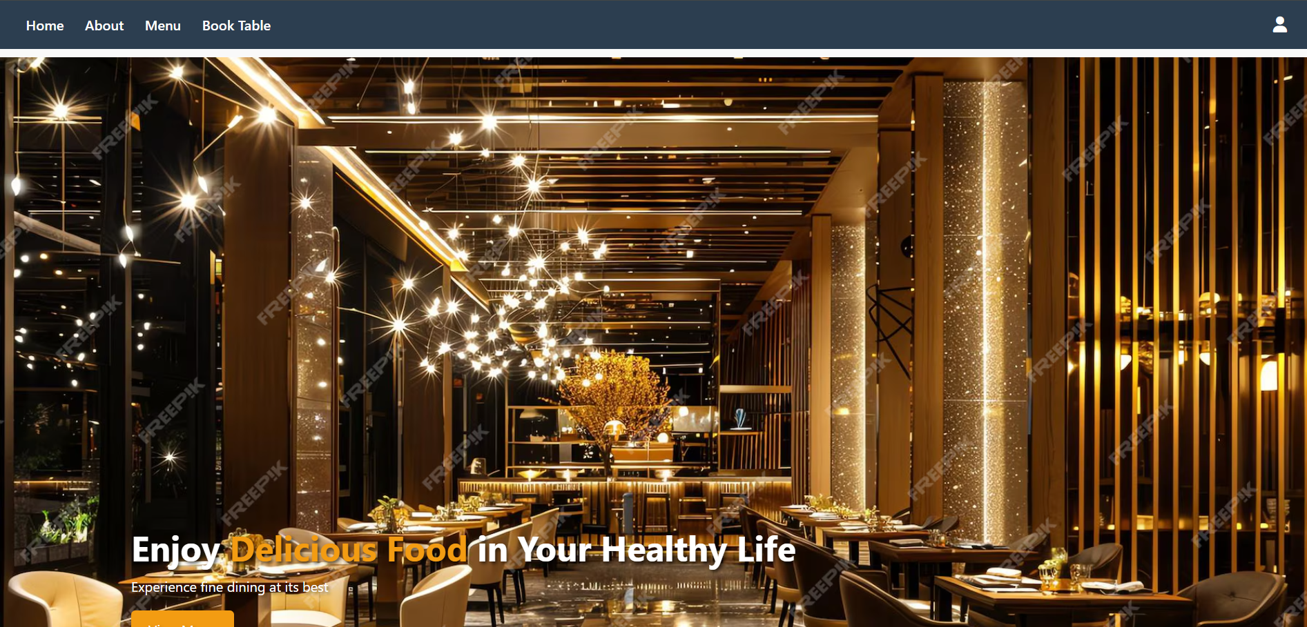

Admin Login:

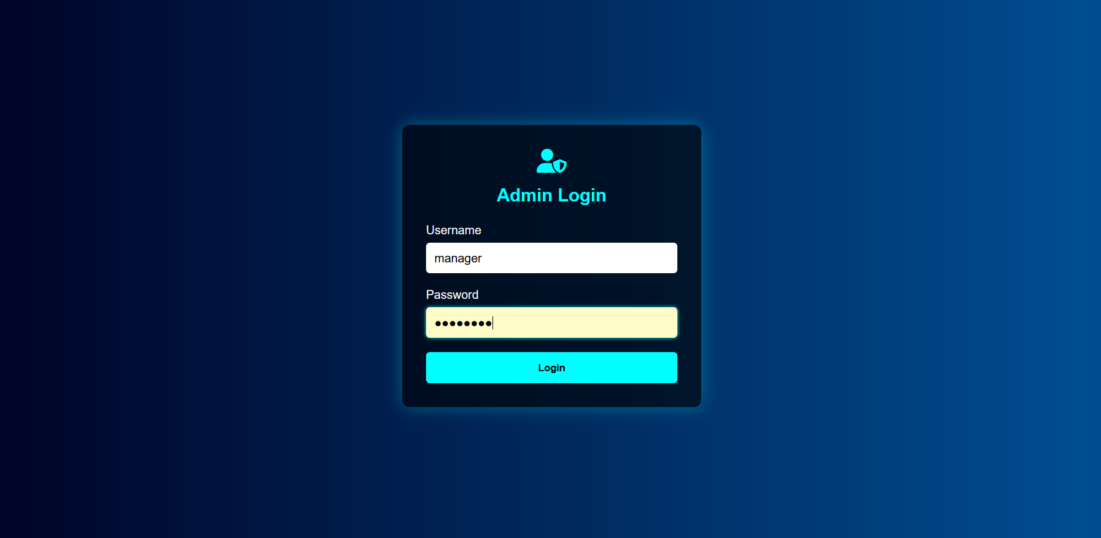

Order List:

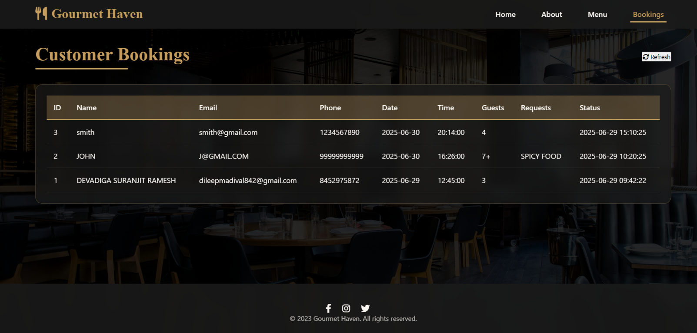

Menu:

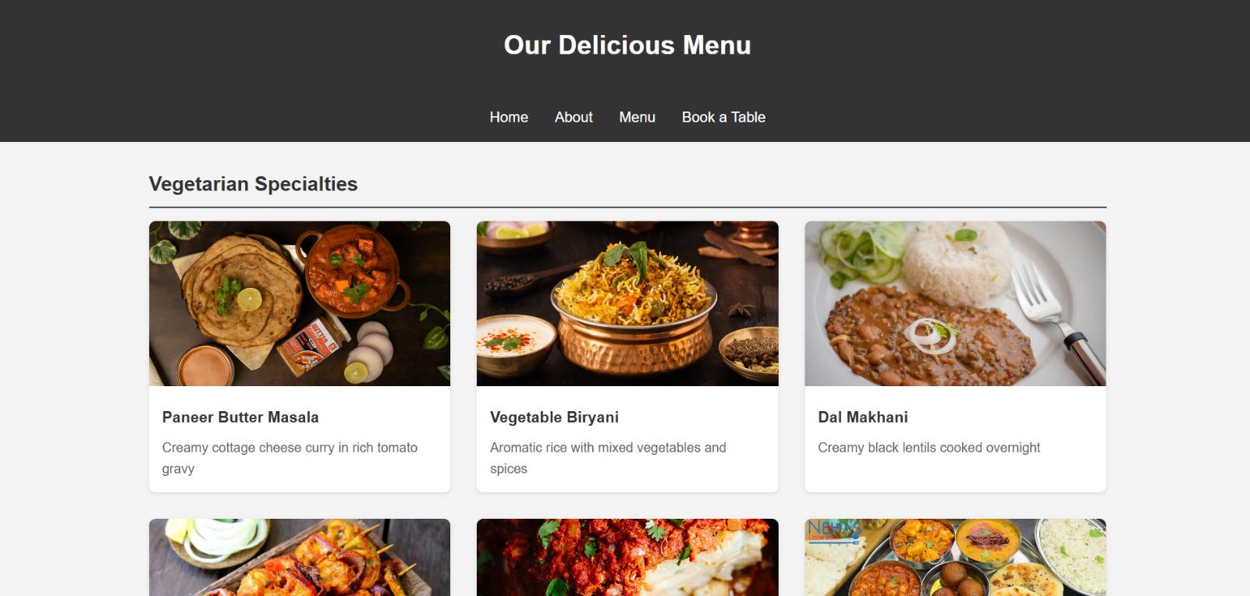
Admin Panel:

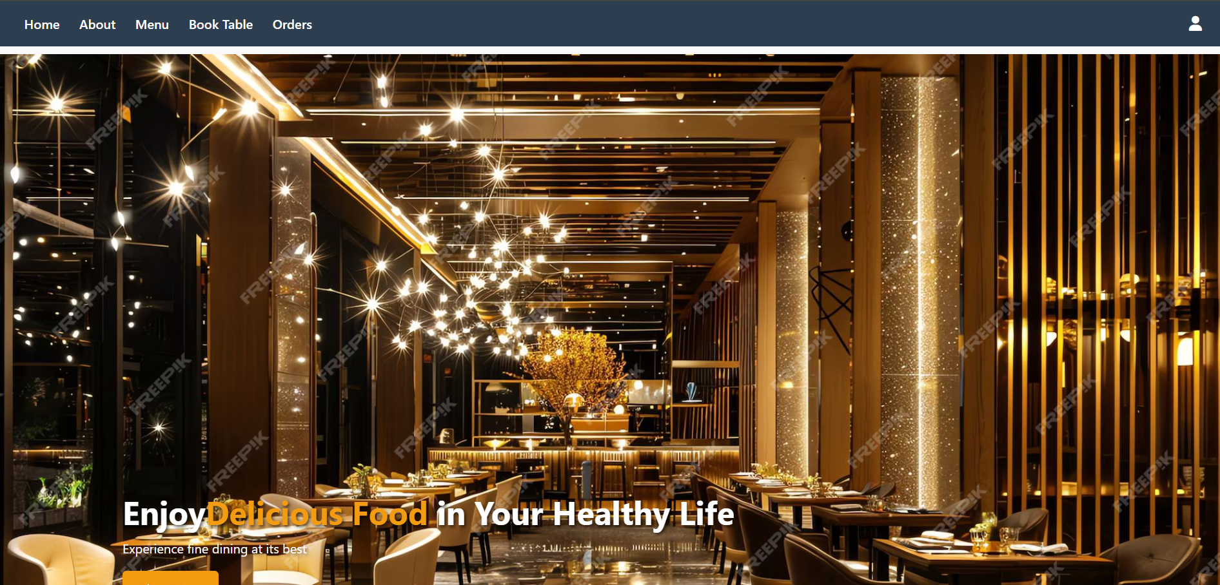

Booking:

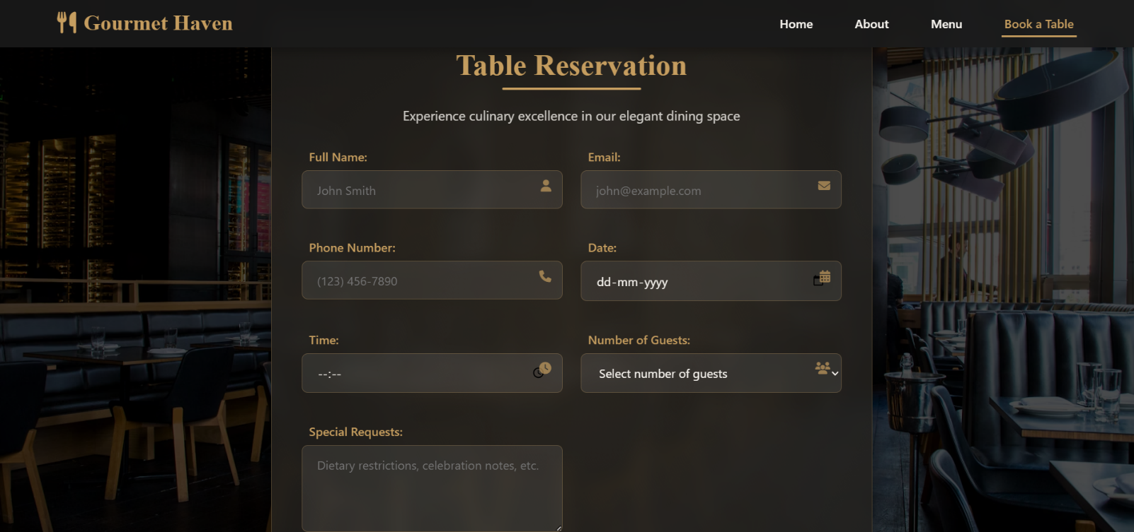

TESTING

INTRODUCTION:
Testing is a critical element of software quality assurance and represents the ultimate review of specification, design and coding. In fact, testing is the one step in the software engineering process that could be viewed as destructive rather than constructive.A strategy for software testing integrates software test case design methods into a well planned series of steps that result in the successful construction of software. Testing
is the set of activities that can be planned in advance and conducted systematically. The underlying motivation of program testing is to affirm software quality with methods that can economically and effectively apply to both strategic to both large and small-scale systems.
The software engineering process can be viewed as a spiral. Initially system engineering defines the role of software and leads to software requirement analysis where the information domain, functions, behavior, performance, constraints and validation criteria for software are established. Moving inward along the spiral, we come to design and finally to coding.
To develop computer software we spiral in along streamlines that decrease the level of abstraction on each turn. A strategy for software testing may also be viewed in the context of the spiral. Unit testing begins at the vertex of the spiral and concentrates on each unit of the software as implemented in source code. Testing progress by moving outward along the spiral to integration testing, where the focus is on the design and the construction of the software architecture. Talking another turn on outward on the spiral we encounter validation testing where requirements established as part of software requirements analysis are validated against the software that has been constructed. Finally we arrive at system testing, where the software and other system elements are tested as a whole.

TESTING OBJECTIVE:
Verification: A outstanding goal of testing is verification, which allows testers to affirm that the software program meets the various commercial enterprise and technical requirements said by the client earlier than the inception of the venture. These requirements and specs guide the design and improvement of software program, consequently are required to be observed rigorously. Moreover, compliance with these necessities and specs is important for the success of the task in addition to meet the client.
Validation: Confirms that the software performs as anticipated and as in line with the requirements of the clients. Validation involves checking the comparing the very last output with the predicted output and then making necessary changes if there is a difference among the two.
Defects: The most critical motive of checking out is to find extraordinary defects in the software to save you its failure or crash at some stage in implementation or go live of the project. Defects if left undetected or unattended can harm the functioning of the software and can lead to loss of resources, money, and recognition of the client. Therefore, software program trying out is executed frequently in the course of every level of software improvement to discover defects of numerous kinds.
Compatibility: It helps validate application's compatibility with the implementation- environment, various devices, Operating Systems, person requirements, among other things.
Quality Analysis: Testing enables improve the first-class of the software by constantly measuring and verifying its layout and coding. Additionally, various types of testing strategies are used by testers, which help them attain the preferred software program fine.

TEST REPORTS:

Admin Module Testing:

Input | Test Condition | Test Output | Comments
Login with valid admin credentials | Correct username and password | Admin dashboard loads successfully | Verify admin authentication
Login with invalid credentials | Wrong username/password | Error message displayed | Validate error handling
Booking a table | Fill all required customer details | Table booked successfully | Check for duplicates
Order List | Only Admin can see | Display all Bookings | Validate data accuracy

Integration Testing:

Test No. | Test Description | Expected Output | Actual Output | Comments
1 | Admin login | Redirects to admin dashboard | Success | Verify authentication flow
2 | Users book table | Booking page will open | Success | Confirmation
3 | Admin book table | Booking page will open | Success | Check order list

System Testing:

SI. No | Test Condition | Test Result | Comments
1 | System load and startup | Successful | System initializes correctly
2 | User login/logout | Successful | Sessions managed properly
3 | Data CRUD operations | Successful | Data created, read, updated, deleted
4 | File operations | Successful | Files saved/loaded correctly
5 | Database communication | Successful | Data transactions successful
6 | Security/authentication | Successful | Roles and permissions enforced
7 | System performance | Normal | No performance issues detected

CONCLUSION:

In conclusion, the Restaurant Management System is designed to meet the important needs of restaurant staff, managers, and customers. It helps solve the problems found in traditional manual systems by making everyday tasks like taking orders, managing tables, and updating menus faster and more organized. Modern tools and proper development methods have been used to make sure the system works well and is easy to use. The system focuses on making restaurant operations smoother and more reliable, reducing mistakes and saving time. Right now, the system includes the most important features needed to run a restaurant efficiently. However, it can be improved and expanded in the future to add more advanced features and make it even more helpful and user-friendly.

Bibliography:

- Front End: https://www.codecademy.com/learn
- PHP: https://www.w3schools.com/php/
- Admin & User Login Page: https://youtu.be/9XKRNfPrNpM
- Dashboard Page: https://youtu.be/IqAPhLLd_bM
- About Us Page: https://openai.com/blog/chatgpt/
- Team Member Page: https://youtu.be/H_64n7gY3h0
- PHP Tutorials: https://youtu.be/1SnPKhCdlsU
- ER & Schema: Database Management System Third Edition By Ramakrishnan & Gehrke
- Background Images: https://www.canva.com/
- Xampp : https://youtu.be/jLqBiSDNXO0 & https://www.apachefriends.org/

